Jenkins Challenge -02

Create a Declarative Jenkins parameterized pipeline for simplecustomerapp.

TITLE:
Parameterized pipeline

OBJECTIVE:
To create a parameterized Declarative Jenkins CI/CD pipeline for the simplecustomerapp that allows users to dynamically select the Git branch, application version, and deployment options while automating build, artifact upload, and deployment.

PREREQUISITES:
• Jenkins installed and running
• Git installed on Jenkins server
• Maven installed on Jenkins server
• Git repository available:
https://github.com/betawins/hiring-app.git
• Nexus Repository configured
• Apache Tomcat server running
• Required credentials added in Jenkins:
- Nexus credentials
- Tomcat credentials

STEP-BY-STEP-IMPLIMENTATION:
Created a job simple-customer-app-parametrized

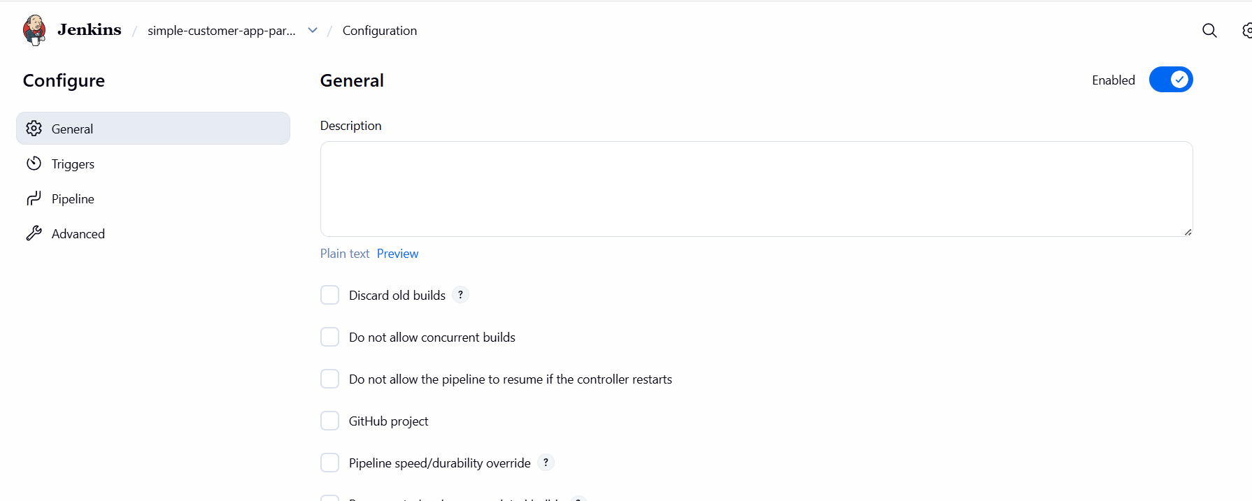

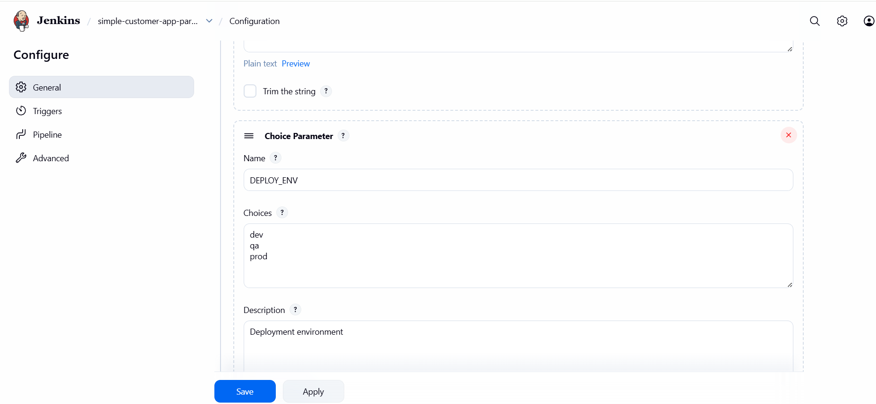

PIPELINE:

pipeline {
agent any

parameters {
string(name: 'GIT_BRANCH', defaultValue: 'main', description: 'Git branch to build')
string(name: 'VERSION', defaultValue: '0.1', description: 'Application version')
choice(name: 'DEPLOY_ENV', choices: ['dev', 'qa', 'prod'], description: 'Deployment environment')
booleanParam(name: 'SKIP_TESTS', defaultValue: true, description: 'Skip unit tests')
}

environment {
// Maven
MVN_HOME = "/opt/maven/bin/mvn"

// Nexus
NEXUS_URL = "http://98.93.29.69:8081/repository/simple-customer-app/"
GROUP_ID = "in.javahome"
ARTIFACT = "hiring"

// Tomcat
TOMCAT_URL = "http://172.31.31.11:8080"
CONTEXT = "hiring"
}

stages {

stage('Clean Workspace') {
steps {
deleteDir()
}
}

stage('Git Clone') {
steps {
git branch: "${params.GIT_BRANCH}",
url: 'https://github.com/betawins/hiring-app.git'
}
}

stage('Build WAR') {
steps {
sh """
${MVN_HOME} clean package ${params.SKIP_TESTS ? '-DskipTests' : ''}
"""
}
}

stage('Upload to Nexus (Release)') {
steps {
withCredentials([usernamePassword(
credentialsId: 'nexus_credential',
usernameVariable: 'NEXUS_USER',
passwordVariable: 'NEXUS_PASS'
)]) {
sh """
cat > settings.xml <<EOF
<settings>
<servers>
<server>
<id>simple-customer-app</id>
<username>\${NEXUS_USER}</username>
<password>\${NEXUS_PASS}</password>
</server>
</servers>
</settings>
EOF

${MVN_HOME} deploy:deploy-file \
-s settings.xml \
-DgroupId=${GROUP_ID} \
-DartifactId=${ARTIFACT} \
-Dversion=${params.VERSION} \
-Dpackaging=war \
-Dfile=target/${ARTIFACT}.war \
-DrepositoryId=simple-customer-app \
-Durl=${NEXUS_URL}
"""
}
}
}

stage('Deploy to Tomcat (Manager API)') {
when {
expression { params.DEPLOY_ENV != '' }
}
steps {
withCredentials([usernamePassword(
credentialsId: 'tomcat_credentials',
usernameVariable: 'TC_USER',
passwordVariable: 'TC_PASS'
)]) {
sh """
echo "Deploying to environment: ${params.DEPLOY_ENV}"

curl -u \${TC_USER}:\${TC_PASS} \
"${TOMCAT_URL}/manager/text/undeploy?path=/${CONTEXT}" || true

curl -u \${TC_USER}:\${TC_PASS} \
-T target/${ARTIFACT}.war \
"${TOMCAT_URL}/manager/text/deploy?path=/${CONTEXT}&update=true"
"""
}
}
}
}

post {
success {
echo " CI/CD SUCCESS | Branch: ${params.GIT_BRANCH} | Version: ${params.VERSION} | Env: ${params.DEPLOY_ENV}"
}
failure {
echo " CI/CD FAILED | Branch: ${params.GIT_BRANCH} | Version: ${params.VERSION}"
}
}
}

